Advance Machine Learning Techniques for Big Data Analysis
A Research Report
Submitted in partial fulfillment of the
Requirements for the award of the Degree of
MSATER OF SCIENCE (INFORMATION TECHNOLOGY)
By
Mohd Sahbaz Chaudhary
Roll Number: 801
Under the esteemed guidance of
Ms. Kirti Yadav
Designation

DEPARTMENT OF INFORMATION TECHNOLOGY
SHRI RAJASTHANI SEVA SANGH’S
SMT.PARMESHWARIDEVI DURGADUTT TIBERWALA LIONS JUHU COLLEGE OF ARTS, COMMERCE & SCIENCE
(Affiliated to University of Mumbai)
(Autonomous)
JB NAGAR, ANDHERI EAST, MUMBAI MAHARASHTRA - 400059
2025 - 26

Sr. No. | Contents | Page No.
1 | INTRODUCTION | 3
2 | Need for Advanced Machine Learning in Big Data Analysis | 4
3 | Advanced Machine Learning Techniques | 5
4 | Applications of Advanced Machine Learning in Big Data | 6
5 | CONCLUSION | 7
TABLE OF CONTENTS

Overview of Big Data and Machine Learning

Big data refers to extremely large and complex datasets that are characterized by high volume, velocity, and variety. These datasets are generated from sources such as social media, sensors, online transactions, and digital platforms. Analyzing big data using conventional methods is difficult due to its scale and complexity.
Machine learning is a branch of artificial intelligence that enables systems to learn from data and improve performance without explicit programming. By applying machine learning techniques, patterns and knowledge can be discovered automatically from large datasets. The integration of machine learning with big data analytics has become essential for organizations seeking data-driven decision-making.
In addition, the combination of big data and machine learning enables organizations to handle both structured and unstructured data more effectively. Advanced machine learning techniques are designed to work in distributed environments, allowing data to be processed across multiple systems simultaneously. This capability is especially important in big data analytics, where data is continuously generated and needs to be analyzed in a timely manner. By integrating machine learning with big data platforms, researchers and organizations can gain deeper insights, improve operational efficiency, and support intelligent and automated decision-making processes.

- Advantages of Advanced Machine Learning Techniques
- Capable of processing very large and complex datasets
- Provides higher accuracy compared to traditional methods
- Automatically identifies patterns and relationships in data
- Supports real-time and predictive data analysis
- Scales efficiently using distributed and parallel computing
- Reduces manual effort in data processing and feature extraction
- Improves decision-making in data-driven applications

Need for Advanced Machine Learning in Big Data Analysis
As the size and complexity of data increase, basic machine learning algorithms face limitations related to scalability, processing time, and accuracy. Advanced machine learning techniques are required to efficiently analyze big data and extract high-quality insights.
Data visualization improves decision-making by enabling faster analysis and comparison of information. It enhances communication by presenting research results in a visually appealing and clear format. Visualization also supports exploratory data analysis by helping researchers identify trends, correlations, and anomalies effectively. As a result, data visualization has become an indispensable tool in modern research methodology.

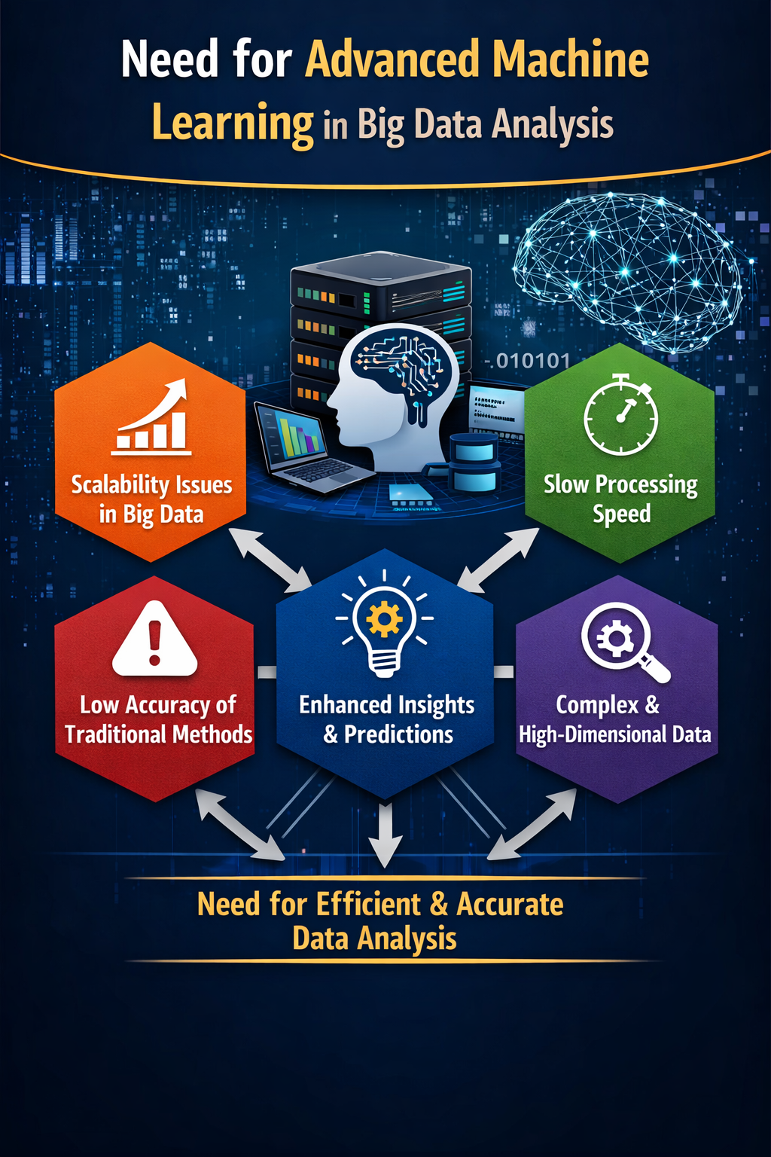

- Advanced Machine Learning Techniques

3.1 Deep Learning Techniques
Deep learning is an advanced subset of machine learning that uses artificial neural networks with multiple hidden layers. These models are capable of learning complex patterns from large datasets. Deep learning techniques such as convolutional neural networks and recurrent neural networks are widely used for image processing, speech recognition, and natural language processing in big data environments.

3.2 Ensemble Learning Methods
Ensemble learning combines multiple machine learning models to improve prediction performance. Techniques such as bagging, boosting, and random forests are commonly used ensemble methods. By integrating multiple models, ensemble learning reduces errors and increases robustness when analyzing large-scale data.

3.2 Distributed Machine Learning
Distributed machine learning techniques are designed to process data across multiple computing nodes. These methods enable machine learning algorithms to scale efficiently for big data applications. Frameworks such as Hadoop and Spark support distributed training of machine learning models, allowing faster processing of massive datasets.

Applications of Advanced Machine Learning in Big Data

Advanced machine learning techniques are applied in various domains. In healthcare, they are used for disease prediction, medical image analysis, and personalized treatment. In finance, machine learning supports fraud detection, risk assessment, and algorithmic trading.
In business analytics, machine learning helps analyze customer behavior, recommendation systems, and demand forecasting. Other applications include smart cities, cybersecurity, social media analysis, and scientific research.

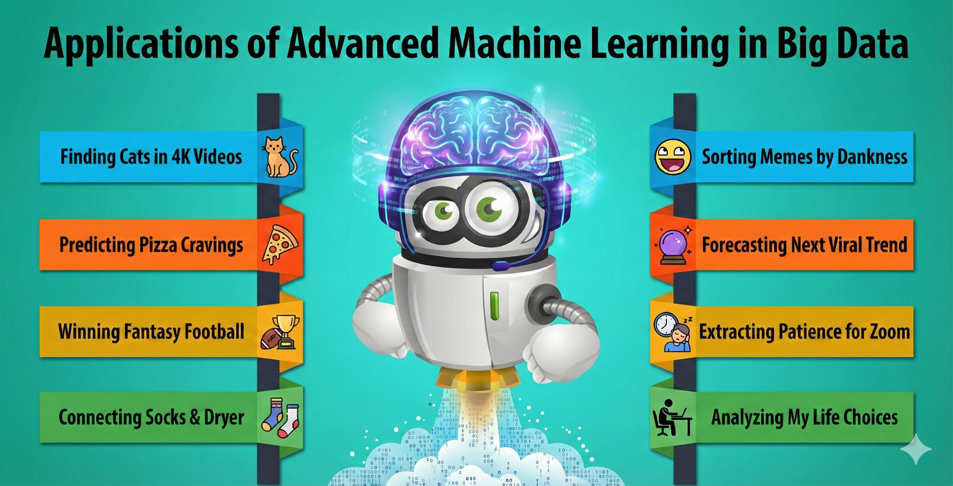

CONCLUSION
Advanced machine learning techniques have become essential for effective big data analysis. This research paper discussed various advanced approaches, tools, and applications that enable efficient processing and analysis of massive datasets. Although challenges exist, continuous advancements in algorithms, computing power, and data management technologies are expanding the scope of machine learning in big data analytics. The effective use of advanced machine learning techniques will continue to support innovation and data-driven decision-making across multiple industries.

